man open 🡪 library files present in linux

man socket 🡪 library files of socket present in linux

fork 🡪 creates child process

shmget 🡪 system call used to get shared memory access

man shmat 🡪 attach , detach process

user apps always run in user mode 🡪 certain permissions

program 🡪 passive ,,,, files on disk

process 🡪 active ….. after execution (something in Ram memory)

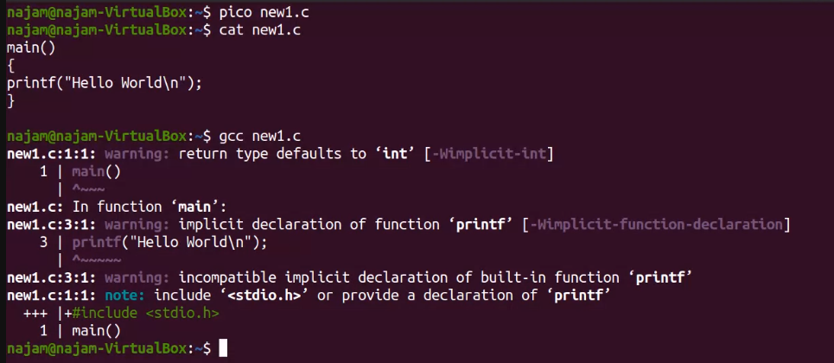

-0 newone 🡪 a.out se nhi bnaygi file

Process bnty wqt full control user mode se kernel mode main

0 -> success

-1 -> error code

std

0 -> input

1 -> output

2 -> error